

LICENSURE EXAMINATION FOR PROFESSIONAL TEACHERS
SEPTEMBER 20, 2026

GURONG PINOY: PROFESSIONAL EDUCATION REVIEWER
(Session 10: May 20, 2026)

1. Which curriculum model is most associated with a grassroots approach to curriculum
development?
- Tyler's Model
- Taba's Model
- Wheeler's Model
- Saylor's Model

CURRICULUM MODELS
Curriculum Model | Core Approach | Key Characteristic / Focus | Exam Keyword Mnemonic | Best Used For
Tyler’s Model | Linear & Deductive | Focuses entirely on predefined learning objectives. | TARGET/ OBJECTIVE/ LINEAR | Standardized testing and linear structures.
Taba’s Model | Inductive & Grassroots | Led by teachers starting with diagnosing student needs. | TEACHER | Teacher-centered curriculum design.
Wheeler’s Model | Cyclical & Continuous | Evaluation loops back into the objectives continuously. | WHEEL | Dynamic programs requiring frequent changes.
Oliva’s Model | Comprehensive (12-step) | Combines a scheme for curriculum and instructional design. | OVERALL / COMPLETE | Systemic school-wide or district-wide revision.
Saylor’s Model | Systematic & Domain-based | Organizes curriculum goals into 4 distinct domains. | SYSTEM/ DOMAINS | High-level behavioral goal setting by planners.

2. Which curriculum model emphasizes continuous improvement and flexibility?
- Stufflebeam’s CIPP Model
- Tyler’s Model
- Wheeler’s Model
- Taba's Model

STUFFLEBEAM’S CIPP MODEL
- C - Context Evaluation: Identifies the environment, community needs, problems, and baseline goals
- I - Input Evaluation: Assesses the available resources, budgets, personnel, and competing strategy designs
- P - Process Evaluation: Monitors the day-to-day implementation and tracks ongoing classroom execution
- P - Product Evaluation: Measures and interprets the final outcomes, successes, and long-term impacts
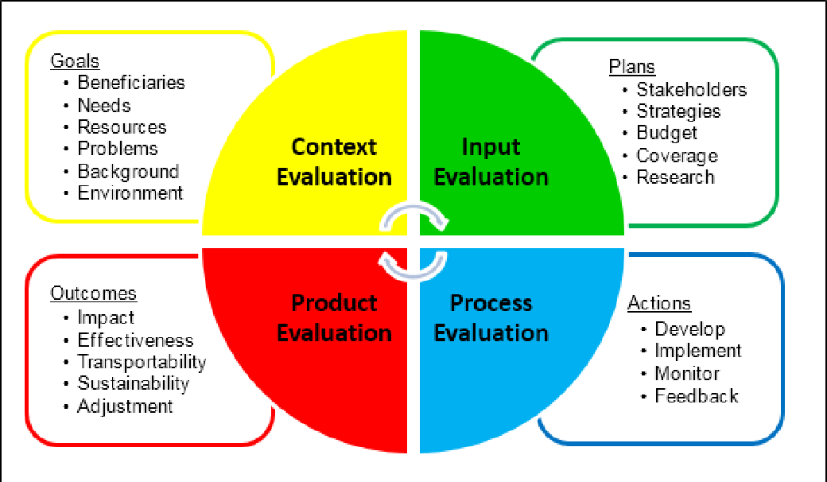

3. What is the central focus of Tyler’s Model of curriculum development?
- Evaluation
- Student needs
- Learning activities
- Objectives

4. What is the first step in Taba’s model of curriculum development?
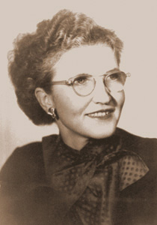
- Formulating objectives
- Diagnosing needs
- Selecting learning activities
- Evaluating outcomes

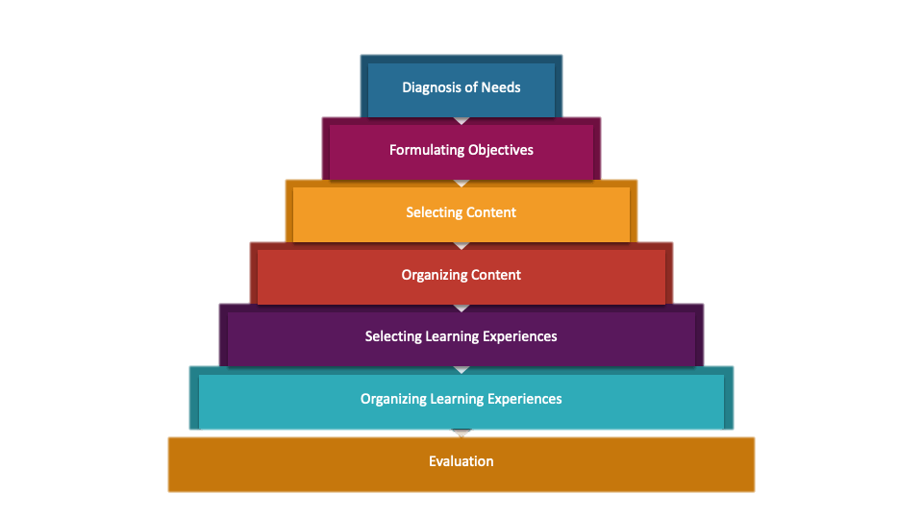
TABA’S MODEL OF CURRICULUM DEVELOPMENT

5. In Stufflebeam’s CIPP model, which component focuses on identifying needs and opportunities?
- Context
- Input
- Process
- Product

6. A pause between asking a question and accepting an answer, designed to allow students to mentally process the question and to formulate their replies.
- wait module
- lag time
- wait time
- wait technique
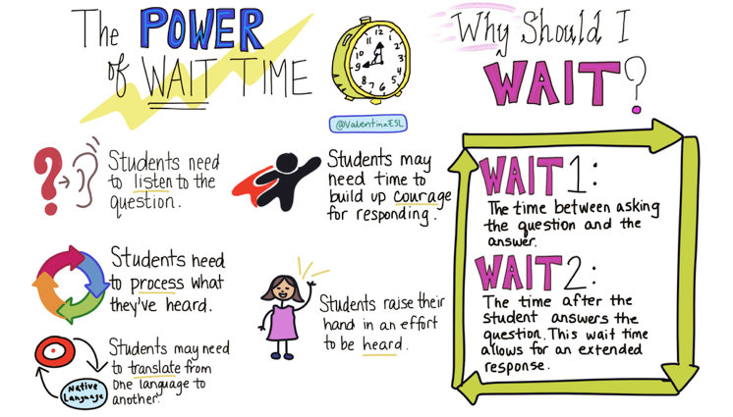

7. A summarizing process that helps students draw conclusions based on what they have learned
- summary
- closure
- case study
- simulation

- Summary- a brief restatement of ideas/concepts
- Closure- connects and concludes what was learned
- Case study- in-depth analysis of a case/situation
- Simulation- imitation of real-life situations

8. The rate at which a teacher presents components of a lesson or the lessons throughout
the day
- wait time
- productive lab
- pacing
- case study

9. It is a structured, systematic, and well-organized procedure designed to facilitate and improve student learning
- Teaching Strategy
- Teaching Approach
- Teaching Method
- Teaching Technique

- A Smart Man Teaches = Approach, Strategy, Method, Techniques

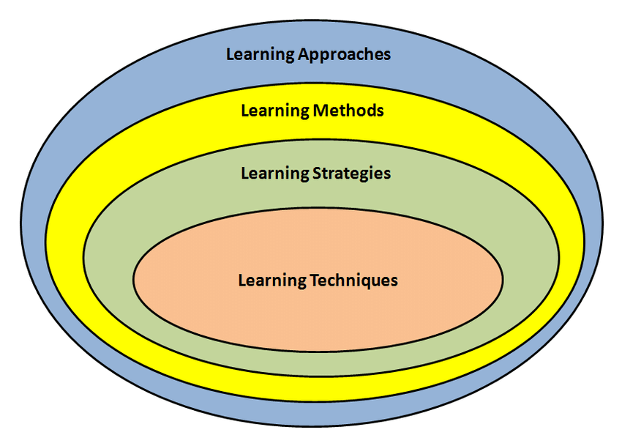

Framework Level | Core Question | Definition | Scope
Approach | Why? | The overarching philosophy or belief system regarding learning. | Broadest / Abstract
Strategy | What is the plan? | The long-term instructional blueprint or layout used to reach goals. | Macro-level / General
Method | How, step-by-step? | A systematic, structured process for executing instruction. | Procedural / Ordered
Technique | With what tool? | The specific micro-activity or personal trick applied on the spot. | Narrowest / Practical

10. What is the focus of inquiry-based learning?
- Students working together to achieve common goal
- Problem-solving and experiential learning
- Discuss ideas and answers with peers
- Freeing class time for activities that involve higher-order thinking

- Inquiry-based learning emphasizes questioning, investigation, and discovery

11. Students answer modules, quizzes, and assignments on their own pace and schedule. They don't need to spend their learning in the classroom with their classmates and teachers. This type of learning is called
- Synchronous learning
- Asynchronous learning
- Collaborative Learning
- Asymmetrical Learning

- Synchronous- in sync or sabay-sabay
- Asynchronous- on your own pace/ aking oras

12. Which of the following is a limitation of models and real objects in teaching and learning?
- They pose problems with storage.
- They make learning more concrete.
- They provide hands-on learning experiences
- They are readily available in the environment, school, and home.

13. Which group of technologies has the highest degree of concreteness?
- Book, imaginative literature, programmed instruction
- Digital video, film, versatile compact disc
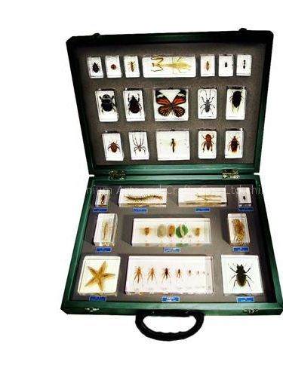
- Video, picture, and television
- Realia

- Concrete: nahahawakan/ tunay
- Abstract: hindi nahahawakan


14. Mrs. Olivarez presented real samples of rocks in her General Science class. What principle did she apply?
- Appropriateness
- Authenticity
- Responsiveness
- Simplicity

- Appropriateness- suitability
- Authenticity- genuine materials
- Responsiveness- addressing learners’ needs
- Simplicity- uncomplicated design

15. Which is NOT a basic consideration in selecting and evaluating the content of an educational technology tool?
- Does it match the content?
- Is there evidence of its effectiveness?
- Will it motivate and maintain interest?
- Can it be easily dismantled?

16. There are several reasons why teachers are reluctant in using electronic media in the teaching-learning process. Which is the most common reason?
- The limited exposure of teachers to new equipment
- Their incompatibility to the diverse needs of the learners
- The difficulty in integrating technology into the curriculum
- The excessive availability of local technology in the community

17. How can educational technology impact student engagement?
- Educational technology has no effect on student engagement.
- Educational technology decreases interaction among students.
- Educational technology can significantly increase student engagement by making learning interactive and personalized.
- Students prefer traditional methods over technology in learning.

18. Juliet didn't put in enough time to memorize her character's rehearsal script for the school performance. As a result, her teacher gave her part to another student. Juliet learns not to repeat the action if she wishes to play a significant part in the future plays. Which law of learning describes the outcome?
- Law of Exercise
- Law of Effect
- Law of Motivation
- Law of Readiness

19. Teacher Marissa, a Mathematics teacher, uses classroom drills to make sure her students understand the mathematical formulas better. What Thorndike's Law of Learning is represented in this activity?
- Law of Exercise
- Law of Effect
- Law of Motivation
- Law of Readiness

20. Nicolle loves games live scrabble, anagram, and password. What kind of intelligence is strong in Nicolle?
- Interpersonal
- Linguistic
- Kinesthetic
- Spatial
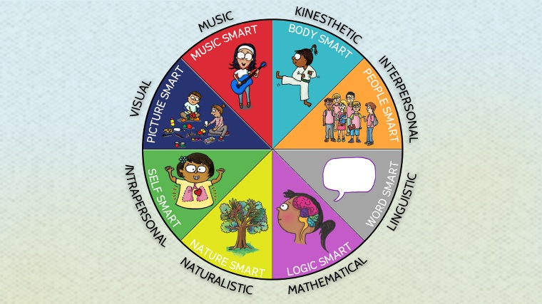

21. Which learning principles is the essence of the theory of multiple intelligences?
- Almost all learners are linguistically intelligent
- Learners have a static IQ
- Learners have different levels of IQ
- Intelligence is not measured in a single form

22. It is a type of lesson plan that reflects all activities, teachers' questions and students' expected answers and is usually done by preservice teacher.
- Detailed lesson plan
- Semi-detailed lesson plan
- Brief lesson plan
- Full length lesson plan

Feature | Detailed Plan | Semi-Detailed Plan | Brief Plan
Concept | Full script. | Step-by-step outline. | Quick checklist.
Content | Every word written out. | Key points and activities. | Only topics and goals.
Dialogue | Includes exact Q&A. | No dialogue written. | No dialogue written.
Best For | New teachers / Evaluation. | Regular daily teaching. | Veteran teachers.
Length | Very long (multi-page). | Medium (1–2 pages). | Short (one index card/page).

23. You've noticed in your new class that students respond to questions even when they're not called. You've also noticed that they always shout "Ma'am" to get your attention and laugh every time their classmate makes mistakes in answering questions. What are you going to do to stop this malpractice?
- Write a letter to parents regarding the misbehavior of their children
- Don't mind the misbehavior of the students
- Establish the rules for the class to observe
- Send the pupils who have misbehavior to the guidance counselor

24. What is the main developmental task during adolescence according to Erikson?
- Developing trust
- Establishing identity
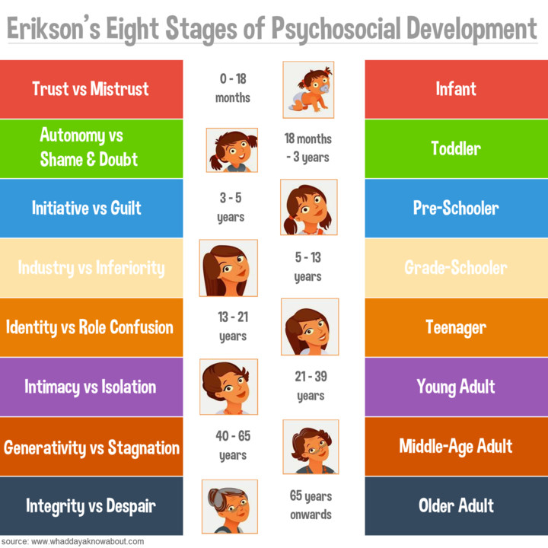
- Gaining autonomy
- Generativity
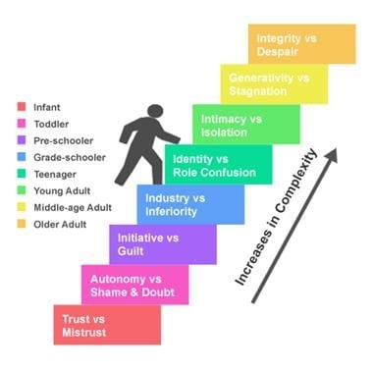

ERIKSON'S 8 STAGES OF PSYCHOSOCIAL DEVELOPMENT (HoW PoCoFooLCoW)
Stage & Age | Psychosocial Crisis | Key Virtue | Core Task / Behavioral Trigger
1. Infancy  (0–1.5) | Trust vs. Mistrust | Hope | Maternal care; feeding; bonding; building security.
2. Toddler  (1.5–3) | Autonomy vs. Shame & Doubt | Will | Toilet training; choice-making (holding/letting go); saying "No!".
3. Preschool  (3–5) | Initiative vs. Guilt | Purpose | Exploring; asking "Why?"; role-playing; inventing games.
4. School Age  (5–12) | Industry vs. Inferiority | Competence | Schoolwork; making/building things; peer comparison.
5. Adolescence  (12–18) | Identity vs. Role Confusion | Fidelity | Finding peer groups; career choices; "Who am I?".
6. Young Adult  (18–40) | Intimacy vs. Isolation | Love | Committing to a partner; deep friendships; marriage.
7. Middle Adult  (40–65) | Generativity vs. Stagnation | Care | Parenting; mentoring; teaching; giving back to society.
8. Late Adult  (65+) | Integrity vs. Despair | Wisdom | Retrospective life review; facing aging/death with peace.

25. A teacher notices that a student feels discouraged despite trying hard. This may indicate a conflict in which stage?
- Industry vs. Inferiority
- Intimacy vs. Isolation
- Initiative vs. Guilt
- Integrity vs. Despair

26. What is the positive virtue gained from successfully resolving the Trust vs. Mistrust stage?
- Hope
- Love
- Will
- Purpose

27. Teacher Jessa modifies her lesson for a student with hearing impairment by providing visual aids and written instructions. What domain is evident?
- Learning Environment
- Diversity of Learners
- Curriculum and Planning
- Assessment and Reporting

PHILIPPINE PROFESSIONAL STANDARDS FOR TEACHERS (PPST) CoLDCACoPe
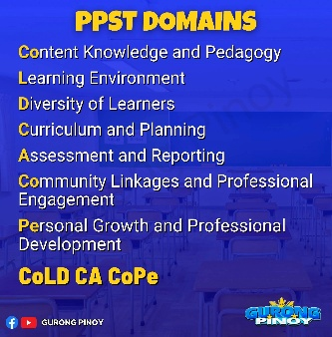
- Content and Pedagogy
- Learning Environment
- Diversity of Learners
- Curriculum and Planning
- Assessment and Reporting
- Community Linkages and Professional Engagement
- Personal growth and Professional Development

28. During class, Teacher Leo ensures that all students feel safe and free to express themselves. What domain is shown?
- Learning Environment
- Community Linkages
- Curriculum and Planning
- Diversity of Learners

29. Which of the following is an example of a performance-based assessment?
- Use of a scantron answer sheet in chemistry class
- Written book report in English class
- Oral presentation in history class
- A True/False exam in history class

30. An assessment used to evaluate the effectiveness of instruction at the end of a specific course is referred to as a _____ assessment.
- formative
- summative
- scholastic aptitude
- general aptitude

